Objective: Determine the concentration of a household vinegar solution.
_________________________________________________________________________________
- Set up titration burette system.
  - Known base is NaOH with a concentration of ________M to be added to burette
  - Use ____ mL of vinegar solution to be added to beaker.
  - Add pH meter.

- You will be adding the base to the vinegar in small amounts recording the volume and the pH over the course of the titration. (1st trial: test pH every 2ml, 2nd trial: larger amounts until you reach close to equivalence then every ½ ml.)
  - Add pH
  - Stir
  - Hit “keep” button
  - Repeat.
- Print graph. Printer across the hall is HHS-E116. (staple to this sheet when submitted )
- Repeat with second trial.
Calculations and questions.
- Determine the concentration of the vinegar for each trial.
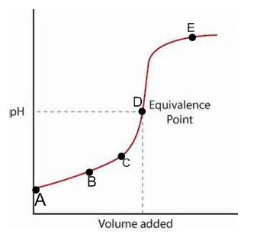

- Draw the particulate drawing at various points in the graph.
a b

c.

d. e.

